Invention Disclosure Format (IDF)-B
Vellore Institute of Technology – IPR & TT Cell
1. Title of the Invention
A Method and System for Label-Free Detection of Examination Malpractice Using Self-Supervised Predictive Residual Analysis of Multi-Modal Desk-Level Sensor Signals.
2. Field / Area of Invention
The present invention relates to examination security systems and academic integrity enforcement. More specifically, it pertains to a method by which a desk-level sensing system detects malpractice by learning the pattern of normal examination activity and identifying deviations from it, without requiring any labelled examples of cheating during training. The invention further relates to the correlation of such deviations across neighbouring desks to detect collusion between candidates.
3. Prior Patents and Publications from Literature
The following table summarises the closest known prior art and identifies the gap addressed by the present invention.
No. | Reference (Patent / Publication) | Key Features & Relevance | Notes / Implications
1 | CCTV-based examination surveillance systems | Visual monitoring of examinee behaviour at hall level | Cannot detect concealed electronic devices, low-power signals, or covert audio; blind to what is not visible.
2 | RF signal jammers for examination halls | Block mobile and wireless communication during exams | Preventive, not detective; may interfere with authorised systems; ineffective against passive or non-RF methods.
3 | AI-based video analytics for cheating detection (supervised) | Computer vision and behaviour analysis trained on labelled cheating footage | Requires labelled malpractice data, which does not exist at scale; models learn only the specific cheating types staged in training.
4 | Handheld metal detectors and electronic scanners | Detect presence of metallic or electronic objects on individuals | Manual, intrusive, point-in-time; unsuitable for continuous monitoring during an examination.
5 | Acoustic / ultrasonic communication detection | Detect abnormal sound patterns and ultrasonic signals | Typically single-modality; not fused with electromagnetic sensing; no per-desk deployment.
6 | Multi-sensor exam desk with acoustic + EM signatures (base disclosure) | Desk-embedded acoustic and electromagnetic sensors; decision by “predefined thresholds or learned models” | Does not specify how detection operates without labelled malpractice data; scores each desk independently, so cannot separate collusion from coincidental anomaly.

The common limitation across the supervised approaches (entries 3 and 6) is a dependence on labelled malpractice data. Genuine cheating is rare, adversarial, and deliberately concealed, so a representative labelled corpus of malpractice cannot be assembled in practice. A detector trained on such data can only recognise the specific cheating methods that were staged and labelled; it does not generalise to novel methods. No prior art known to the inventor performs desk-level malpractice detection by learning normal activity alone, nor correlates detection signals across desks to distinguish collusion from coincidental anomaly.
4. Summary and Background of the Invention (Gap / Novelty)
Examination malpractice has grown more sophisticated with the miniaturisation of electronics. Concealed micro-earpieces, smartwatches, and Bluetooth accessories are difficult to detect by inspection, and supervised detection systems face a fundamental data problem: there is no large, representative, labelled dataset of cheating, and there never will be, because cheating is rare and actively hidden. Any system trained to recognise cheating from labelled examples is therefore limited to the exact behaviours it was shown.
The present invention removes this dependence. The system is trained exclusively on recordings of normal examination sessions, which are abundant and require no labelling. A self-supervised model learns to predict the near-future state of the sensor signals from their recent past. During an examination, the error between the model's prediction and the observed signal — the prediction residual — serves as the malpractice score. Because the model has only ever learned what normal activity looks like, any activity unlike normal, including cheating methods never anticipated, produces an elevated residual. This inverts the data problem: instead of the impossible task of collecting every kind of cheating, the system need only observe ordinary behaviour.
The proposed system comprises: a desk body with embedded acoustic and electromagnetic sensors, optionally augmented by a behavioural sensing module where a camera is available; an embedded processing unit executing a self-supervised predictive model; a residual-scoring module that converts prediction error into a malpractice score; a multi-sensor fusion stage; a cross-desk correlation module that compares residual patterns between neighbouring desks; and a communication interface for alert transmission. The distinguishing elements over the prior art are (i) label-free detection by predictive residual, (ii) multi-modal fusion of the residual signal, and (iii) cross-desk residual correlation for collusion detection.
5. Objectives of the Invention
- To detect examination malpractice at desk level without requiring any labelled examples of cheating for training.
- To detect unauthorised communication devices and covert activity through their acoustic and electromagnetic signatures, and optionally through behavioural cues.
- To generalise to novel cheating methods that were not anticipated when the system was built.
- To reduce false alarms by fusing multiple sensing modalities and by requiring corroborating evidence.
- To detect collusion between candidates by correlating detection signals across neighbouring desks — a signal that does not exist at any single desk.
- To provide an honest, quantified operating envelope stating the conditions under which detection is reliable.
6. Working Principle (in Brief)
Each desk continuously produces multi-modal sensor signals: acoustic (including near-ultrasonic energy), electromagnetic (radio-frequency emissions, device-advertisement activity, and signal-strength dynamics), and, where a camera is present, behavioural signals (blink rate, gaze direction, head pose, and fixation). These signals are divided into short time windows. A self-supervised encoder, trained only on normal sessions, embeds the recent window and predicts the near-future change in the signal. The squared error between predicted and observed change is the per-modality residual. Residuals from all modalities are standardised against normal-only statistics and combined into a single malpractice score. When the score exceeds a confidence threshold, the event is logged and an alert is transmitted with desk identifier, timestamp, and severity. Separately, the residual time-series of neighbouring desks are cross-correlated; synchronised elevation on adjacent desks indicates collusion, whereas an isolated elevation on one desk indicates an individual anomaly.
7. Detailed Description of the Invention
Sensing. Acoustic sensors capture sound across a wide band, including near-ultrasonic frequencies used by some covert audio links. Electromagnetic sensors monitor bands associated with consumer devices, capturing radio emissions, device-advertisement rates, and received-signal-strength behaviour. An optional behavioural module derives gaze, blink, head-pose, and fixation features from a camera. In a representative embodiment the signals are sampled at a common low frame rate and grouped into overlapping context windows of approximately seven seconds.
Model. A separate lightweight encoder is provided for each modality. From a context window, the encoder produces a compact embedding, and a predictor estimates the change in the signal over a short future horizon (a pooled prediction several seconds ahead). The model is trained only on normal sessions to minimise the error of this prediction, while a variance-and-covariance regularisation on the embedding prevents the degenerate solution in which the encoder maps every input to the same point. No labelled malpractice is used at any stage of training.
Scoring and fusion. At inference, the prediction error for each modality is the anomaly score. Scores are standardised using statistics gathered from normal calibration data only, then averaged across modalities. Fusing modalities is beneficial because different cheating methods manifest in different channels; combining them improves detection over any single channel and reduces false positives. Optionally, the residual is aggregated over a longer time span within a session, which raises sensitivity to faint but sustained activity without requiring any labels.
Cross-desk correlation. Because a single desk cannot distinguish an individual's brief anomaly from coordinated cheating, the system compares the residual time-series of adjacent desks. Collusion couples the two desks in time — one candidate signals, the other responds after a short lag — producing correlated residual elevations. An isolated anomaly on one desk correlates with nothing. A lagged cross-correlation of adjacent-desk residuals, evaluated per modality and combined, therefore separates collusion from coincidental anomaly. This signal is absent from any single-desk analysis and constitutes an independent detection channel.
Per-hall calibration. Because ambient acoustic and electromagnetic conditions differ between halls, the normal-only statistics used for standardisation are established from an initial interval of each examination and then held fixed, adapting the detector to the specific room.
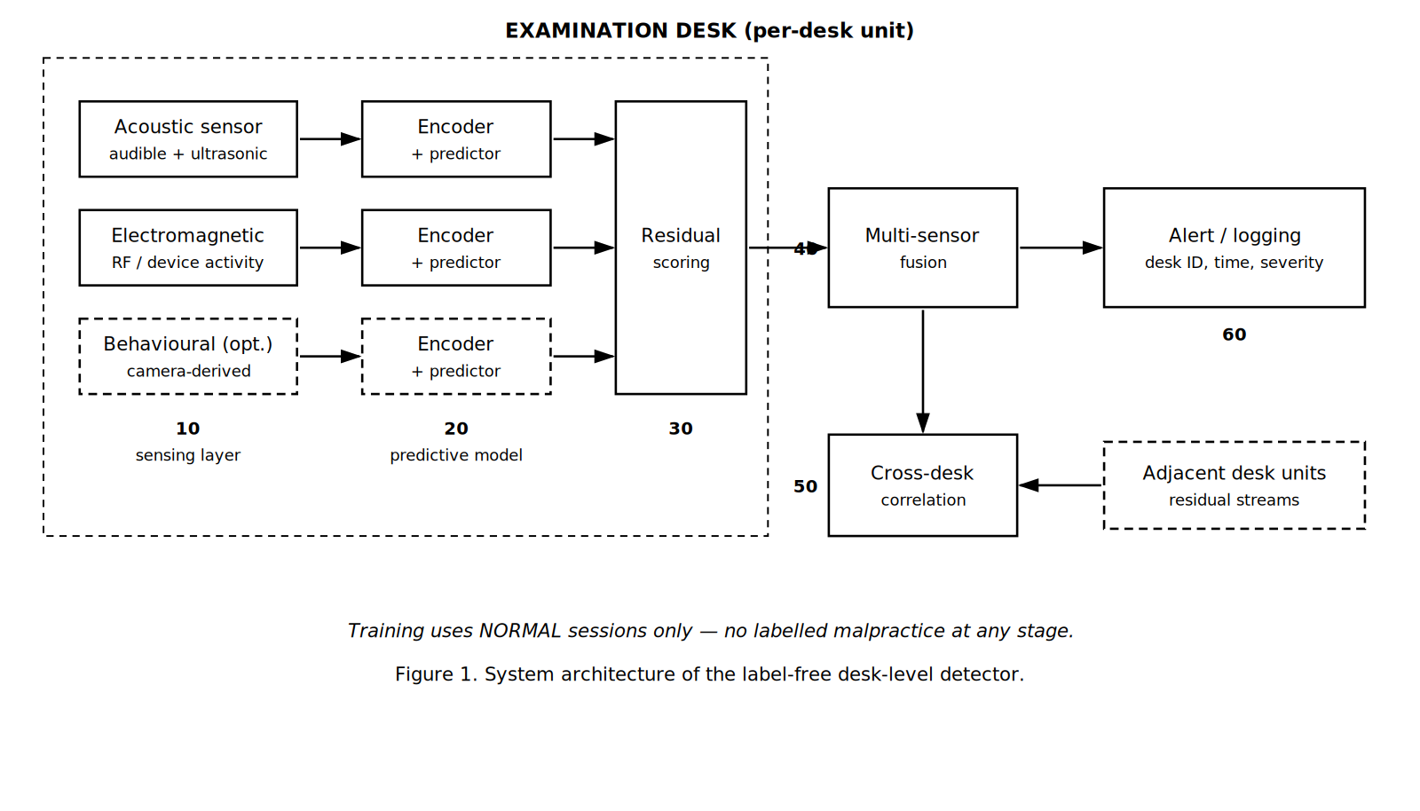
Figure 1. System architecture. Sensing layer (10) feeds per-modality encoders and predictors (20); residual scoring (30) converts prediction error into a score; fusion (40) combines modalities; cross-desk correlation (50) compares neighbouring desks; alerts are issued at (60).
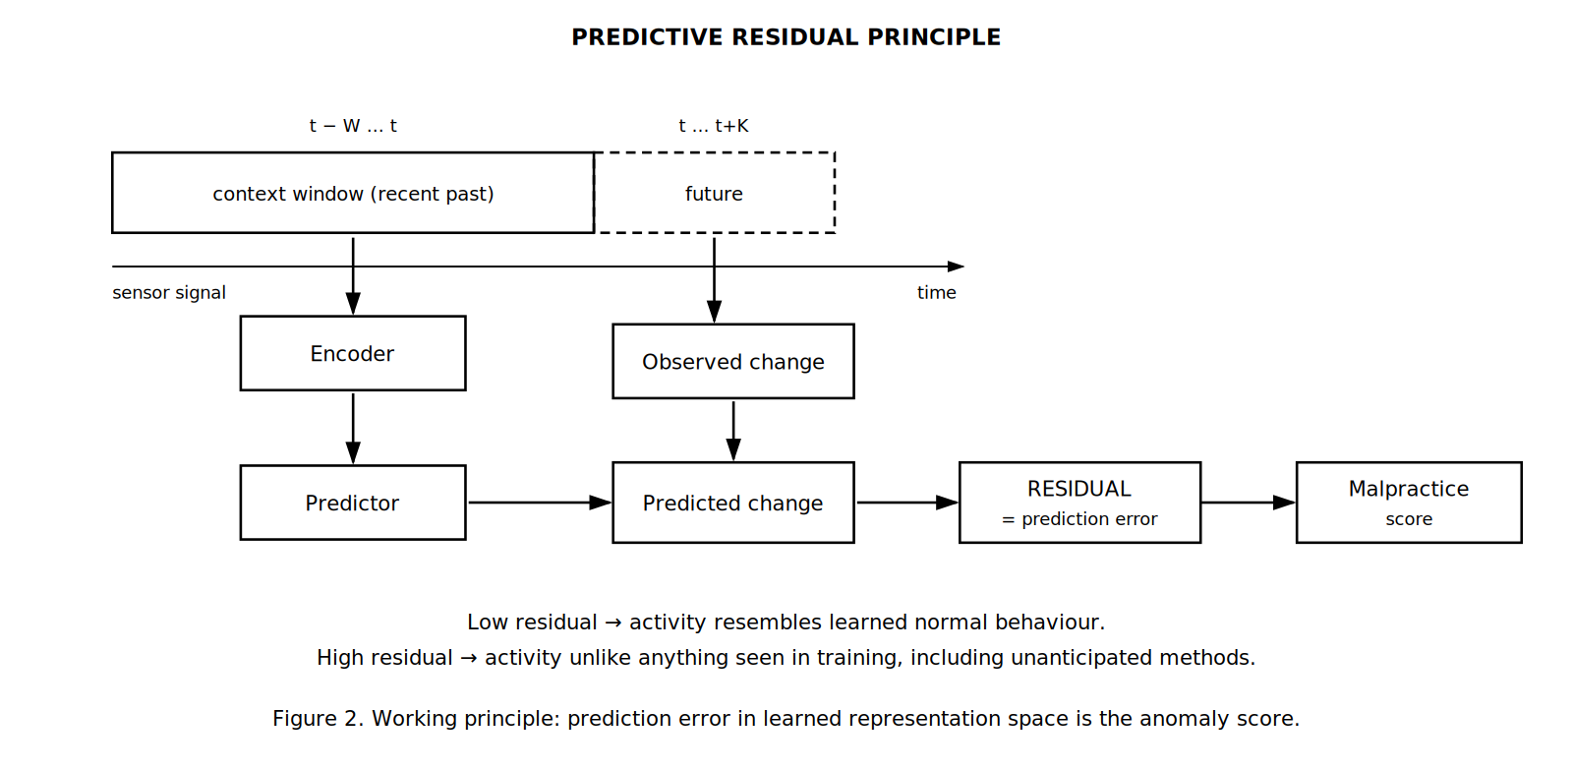
Figure 2. Working principle. The encoder embeds the recent context window and the predictor estimates the near-future change; the discrepancy against the observed change is the residual, which serves as the malpractice score.
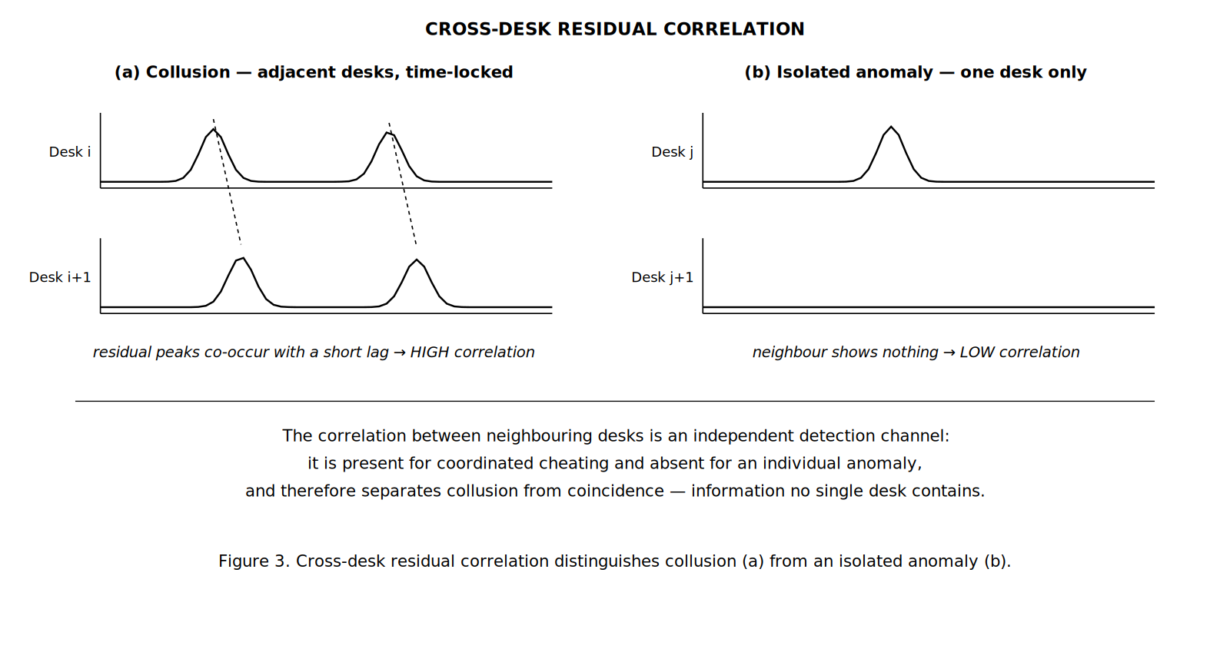
Figure 3. Cross-desk correlation. Colluding candidates on adjacent desks produce time-locked residual elevations (a); an isolated anomaly leaves the neighbouring desk unaffected (b).
8. Simulated Validation Results
The method has been validated on a parametric simulation of desk-level examination signals, in which normal examination activity and concealed-device activity are generated across a range of signal strengths. The validation is computational; no hardware prototype has been constructed. All figures below are stated as reported by the simulation and should be read as evidence that the method functions, not as measurements from a deployed system. Detection quality is reported as AUROC (area under the receiver-operating curve), where 1.0 is perfect ranking and 0.5 is chance.
Task validity. Before evaluating the method, the simulation was audited to confirm that no single sensor feature trivially separates normal from malpractice activity; the largest single-feature separation was small (Cohen's d = 0.16), so any detection must arise from learned temporal structure rather than a single obvious cue. A supervised reference detector, trained from scratch on the same data but permitted to use the malpractice labels, establishes the best achievable performance and serves as a ceiling.
Single-desk detection. The following table compares the label-using reference detector with the present label-free method across decreasing signal strength (SNR). The second figure for the present method includes within-session temporal aggregation.
Signal strength (SNR) | Reference detector (uses labels) | Present method (uses no labels) | Interpretation
1.0 (overt) | 0.946 | 0.705 / 0.781 | Recovers ~75% of the label-using reference with zero labelled malpractice; temporal aggregation raises the figure to 0.781.
0.6 (moderate) | 0.903 | 0.653 / 0.716 | Detection remains clearly above chance as concealment increases.
0.3 (faint) | 0.843 | 0.613 / 0.657 | Weak but non-trivial detection of subtle activity.
0.15 (near noise floor) | 0.797 | 0.541 / 0.571 | Approaches chance; defines the lower limit of the operating envelope.

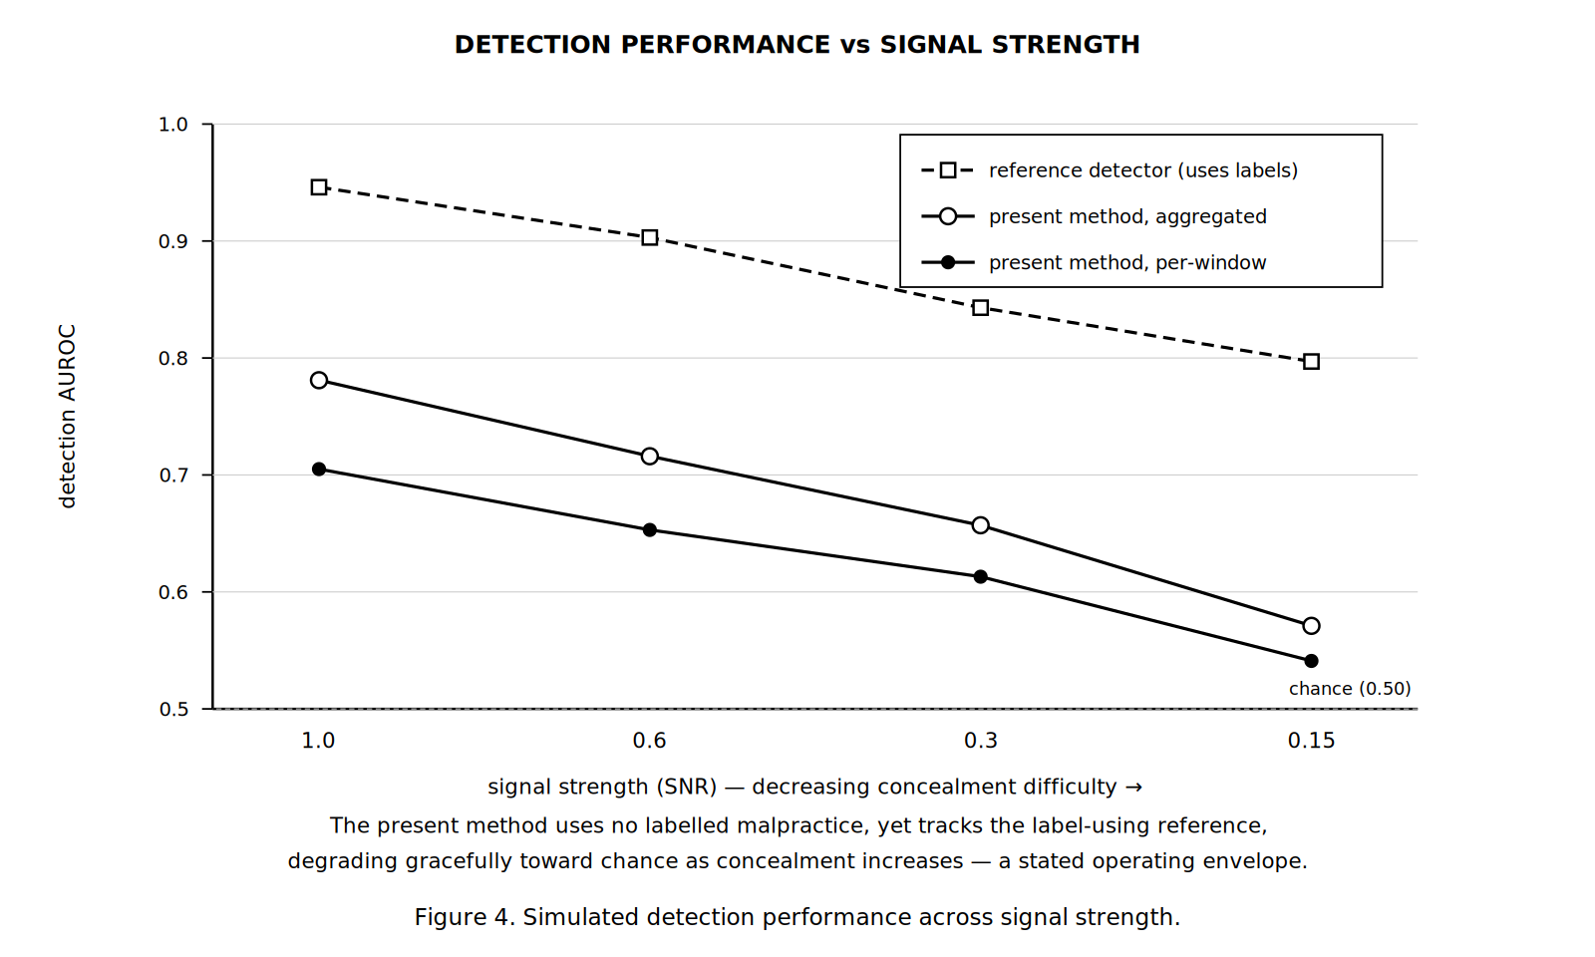
Figure 4. Simulated detection performance across signal strength, compared against a label-using reference detector.
Two observations follow. First, the present method recovers a substantial fraction of the label-using reference's performance while using no labelled malpractice whatsoever, which is the central claim. Second, detection degrades gracefully and monotonically as concealment increases, approaching chance only near the noise floor. This defines an honest operating envelope: the method is a strong detector of overt malpractice and a progressively weaker detector of increasingly subtle activity. The fusion of modalities was confirmed to exceed the best single modality, supporting the multi-sensor claim.
Cross-desk collusion detection. The cross-desk correlation was evaluated on simulated halls containing colluding adjacent pairs together with isolated innocent anomalies acting as distractors. The correlation score separates true colluding pairs from adjacent-but-innocent pairs, with the electromagnetic channel carrying the strongest signal — consistent with the physical mechanism of two paired radio devices — and a combination across channels performing best.
Sensing channel | Colluding pairs (mean corr.) | Innocent pairs (mean corr.) | Separation (AUROC)
Acoustic | 0.098 | 0.098 | 0.468
Electromagnetic | 0.232 | 0.099 | 0.739
Behavioural | 0.154 | 0.095 | 0.650
Combined (per-channel max) | 0.293 | 0.177 | 0.810

The combined cross-desk score separates collusion from coincidence at an AUROC of approximately 0.81, using a signal that is provably absent from any single desk. This directly addresses the false-positive limitation of single-desk detection and constitutes the strongest inventive step of the disclosure. (These figures are from an evaluation of limited sample size; the ordering across channels is robust, while the precise values carry corresponding uncertainty.)
9. Aspects of the Invention Requiring Protection (Claims)
The following elements are considered novel and inventive and are proposed for protection.
Claim 1 (independent). An examination desk comprising a desk body with embedded acoustic and electromagnetic sensors, an embedded processing unit, and a communication module, wherein the processing unit executes a self-supervised predictive model trained exclusively on non-malpractice examination sessions, computes a prediction residual between the model's predicted signal and the observed signal, and generates a malpractice-detection alert from said residual, such that no labelled malpractice data is used in training the model.
Claim 2. The system of Claim 1, wherein prediction residuals from a plurality of sensing modalities are standardised against normal-only statistics and fused into a combined malpractice score, thereby reducing false positives and improving detection over any single modality.
Claim 3. The system of Claim 1, further comprising a cross-desk correlation module that computes a lagged correlation between the prediction-residual time-series of neighbouring desks and identifies collusion when adjacent desks exhibit synchronised residual elevation, thereby distinguishing coordinated cheating from an isolated anomaly using a signal not present at any single desk.
Claim 4. The system of Claim 1, wherein the normal-only statistics used to standardise the residual are established from an initial interval of each examination session and held fixed for that session, adapting the detector to the ambient conditions of the specific examination hall.
Claim 5 (dependent). The system of Claim 1, further comprising a behavioural sensing module deriving gaze, blink, head-pose, and fixation features from a camera, whose prediction residual is fused with the acoustic and electromagnetic residuals of Claim 2.
Claim 6 (method). A method for detecting examination malpractice, comprising: capturing multi-modal desk-level signals during an examination; embedding recent signal windows and predicting a near-future change in the signal using a model trained only on normal sessions; computing the prediction error as a malpractice score; fusing said scores across modalities; correlating residual time-series across neighbouring desks to detect collusion; and transmitting an alert when a score or correlation exceeds a threshold.
Claim 7 (future enhancement). The system of Claim 1, wherein the predictive model is further trained against corrupted or temporally shuffled future signals as explicit negative examples, such that a plausible future is scored as more probable than an implausible one, sharpening the prediction residual used as the malpractice score.
10. Technology Readiness Level (TRL)
The invention has been validated as a self-supervised method on a parametric simulation of desk-level examination signals. It has not been reduced to a hardware prototype and has not been evaluated in a physical examination environment. Its readiness is therefore assessed at TRL 3 — experimental proof of concept — as marked below.
Research |  |  | Development |  |  | Deployment
TRL 1 | TRL 2 | TRL 3 | TRL 4 | TRL 5 | TRL 6 | TRL 7 | TRL 8 | TRL 9
Basic principles observed | Technology concept formulated | Experimental proof of concept | Technology validated in lab | Validated in relevant environment | Demonstrated in relevant environment | Prototype in operational environment | System complete and qualified | Proven in operational environment
✔ | ✔ | ✔

Current TRL: Level 3 – Experimental Proof of Concept (simulated).
Planned advancement: construction of a hardware desk prototype integrating the described sensors; validation on real acoustic, electromagnetic, and behavioural recordings from a controlled examination environment (TRL 4–5); demonstration across a multi-desk hall including live collusion scenarios (TRL 5–6); and pilot deployment with an examining authority (TRL 7+).
— END OF DOCUMENT —

